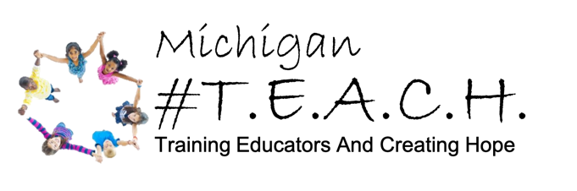
PROHIBITED MTTC TEST LIST

The following tests are for areas currently not offered by #TEACH. Please do not take any of the tests below. If you have questions about the correct test to take for your planned area of study, please contact us at teach@trainingeducators.com

- 064 Autism Spectrum Disorder
- 140 Central Office School Administrator
- 128 Deaf or Hard of Hearing
- 106 Early Childhood Education (General and Special Education)
- 134 Early Childhood General and Special Education (Birth–K)
- 139 Elementary and Secondary (PK–12) School Administrator
- 103 Elementary Education
- 132 English Language Arts (5–9)**
- 130 English Language Arts (7–12)**
- 133 Mathematics (5–9)**
- 131 Mathematics (7–12)**
- 092 Reading Specialist
- 051 School Counselor
- 137 Science (5–9)**
- 138 Science (7–12)**
- 057 Speech and Language Impaired
- 061 Visually Impaired—for testing through 9/29/2024
- 127 Visually Impaired—for testing beginning 9/30/2024
- 135 Professional Knowledge and Skills (5–9)**
- 136 Professional Knowledge and Skills (7–12)**

** Denotes that #TEACH will seek approval for these areas once MDE opens the application cycle. Until our application is submitted and approved by MDE, these areas will remain prohibited.

