Applying for an Interim Teaching Certificate

The process is the same for all educators entering an alternative route program:

1. Educator who does not hold a Michigan teaching certificate and wants to complete a teacher preparation program through an alternative route provider. This educator will apply for the Standard Teaching Certificate after completing the alternative route program.
2. Educator who holds a valid or expired teaching certificate. Needs Interim Teaching Certificate to complete an alternative route program to add an endorsement to their teaching certificate when the program is complete. This educator will apply to add the endorsement to their teaching certificate after completing the alternative route program.

Log into the Michigan Online Educator Certification System (MOECS) at [www.michigan.gov/moecs](http://www.michigan.gov/moecs).

Screen 1

From your home screen click Apply.

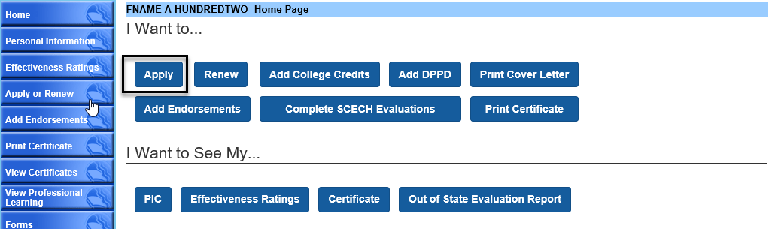

Screen 2

Choose Interim Teaching Certificate – Alternative Route Program in the drop-down menu.

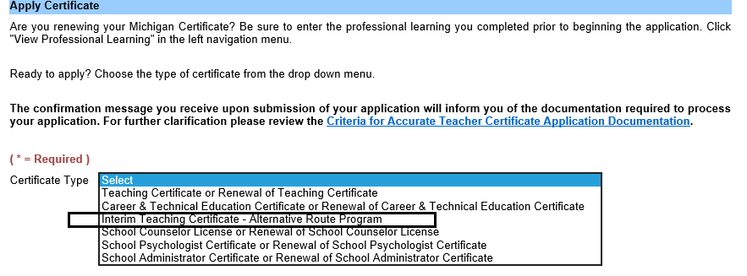

Screen 3

Answer the questions on this screen and choose your alternative route provider from the drop-down menu.

Click Next to continue.

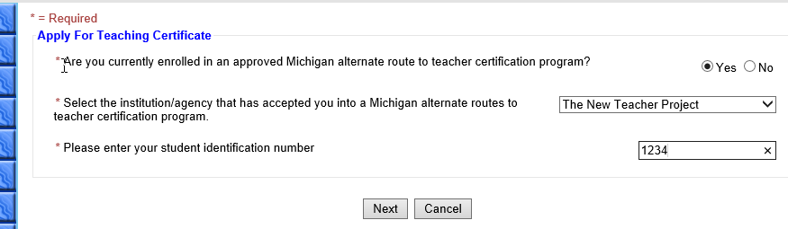

Screen 4

Select whether your program is Elementary or Secondary from the drop-down menu.

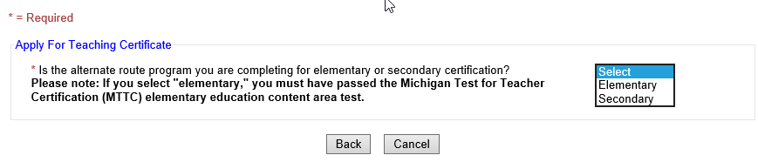

Screen 5

Click Add Endorsement.

* If you are completing the alternative route program to add an endorsement you must choose it here.
* If you are completing the alternative route program as your initial Michigan teaching certificate, and if your program is Secondary, you must choose an endorsement. If your initial Michigan teaching certificate is Elementary, adding endorsements is optional.

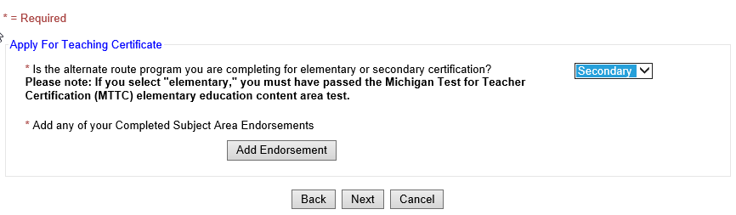

Screen 6

Select your endorsement from the dropdown menu, including the grade level. Click confirm to complete the choice.

Click Next to continue.

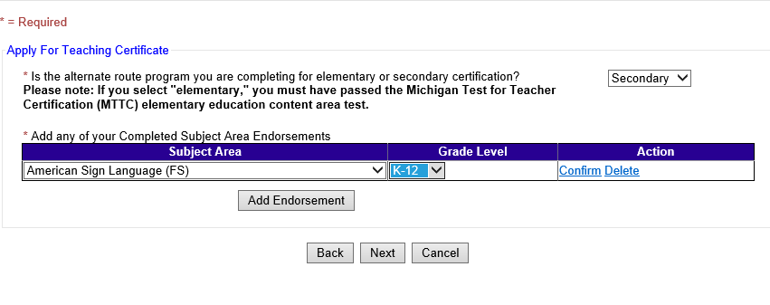

Screen 7

Answer the professional practices questions. Click Next to continue.

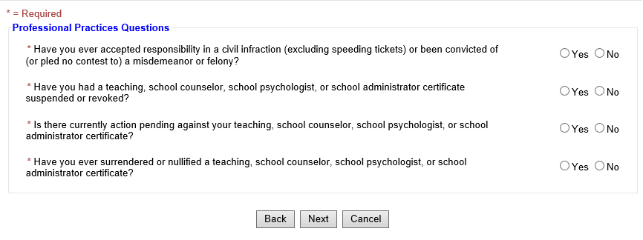

Screen 8

Verify the answers provided on the application. Click next to continue.

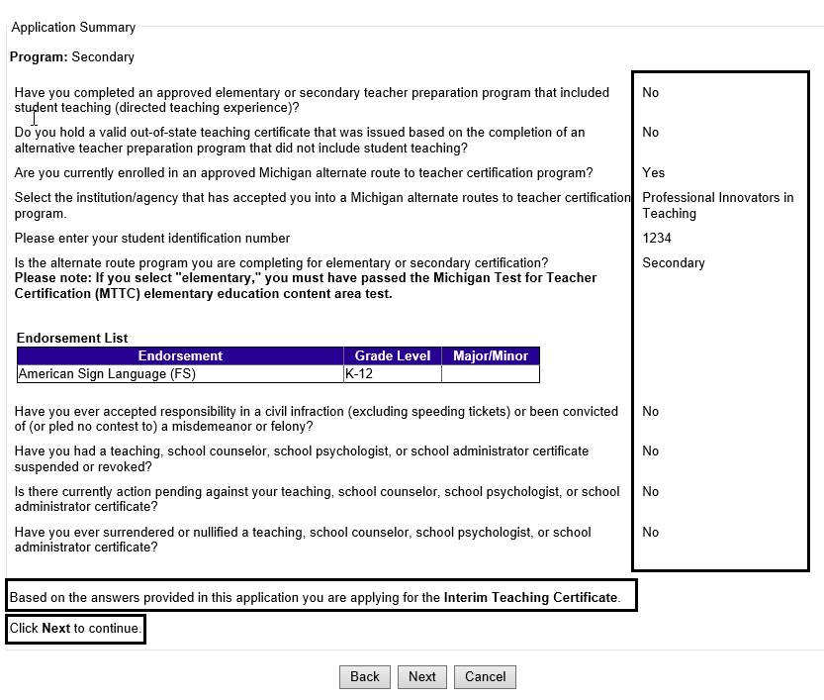

Screen 9

Review the advisory, check both buttons on the left and type your name as your electronic signature.

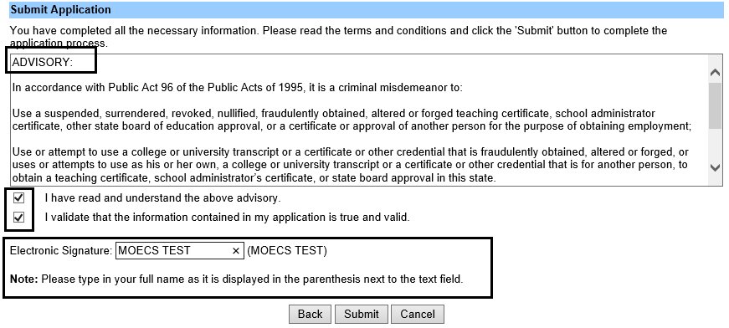

Screen 10

Review the confirmation message.

